Introduction to Data Visualization with Python

import numpy as np
import matplotlib.pyplot as plt
%matplotlib inline
data set
records of undergraduate degrees awarded to women in a variety of fields from 1970 to 2011
- physical_sciences (representing the percentage of Physical Sciences degrees awarded to women each in corresponding year)
- computer_science (representing the percentage of Computer Science degrees awarded to women in each corresponding year)
year=np.arange(1970,2012)
physical_sciences = np.array([ 13.8, 14.9, 14.8, 16.5, 18.2, 19.1, 20. , 21.3, 22.5,
23.7, 24.6, 25.7, 27.3, 27.6, 28. , 27.5, 28.4, 30.4,
29.7, 31.3, 31.6, 32.6, 32.6, 33.6, 34.8, 35.9, 37.3,
38.3, 39.7, 40.2, 41. , 42.2, 41.1, 41.7, 42.1, 41.6,
40.8, 40.7, 40.7, 40.7, 40.2, 40.1])
computer_science = np.array([ 13.6, 13.6, 14.9, 16.4, 18.9, 19.8, 23.9, 25.7, 28.1,
30.2, 32.5, 34.8, 36.3, 37.1, 36.8, 35.7, 34.7, 32.4,
30.8, 29.9, 29.4, 28.7, 28.2, 28.5, 28.5, 27.5, 27.1,
26.8, 27. , 28.1, 27.7, 27.6, 27. , 25.1, 22.2, 20.6,
18.6, 17.6, 17.8, 18.1, 17.6, 18.2])
plt.figure(figsize=[6,3])
# Plot in blue the % of degrees awarded to women in the Physical Sciences
plt.plot(year, physical_sciences, color='blue')

# Plot in red the % of degrees awarded to women in Computer Science
plt.plot(year, computer_science, color='red')

# Display the plot
plt.show()
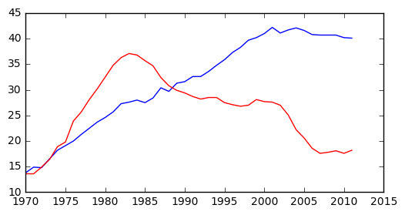

Using axes()
- In calling plt.axes([xlo, ylo, width, height]), a set of axes is created and made active with lower corner at coordinates (xlo, ylo) of the specified width and height. Note that these coordinates are passed to plt.axes() in the form of a list.
- The coordinates and lengths are values between 0 and 1 representing lengths relative to the dimensions of the figure. After issuing a plt.axes() command, plots generated are put in that set of axes.
plt.figure(figsize=[9,3])

# Create plot axes for the first line plot
plt.axes([0.05,0.05,0.425,0.9])

# Plot in blue the % of degrees awarded to women in the Physical Sciences
plt.plot(year,physical_sciences, color='blue')

# Create plot axes for the second line plot
plt.axes([.525,0.05,0.425,0.9])

# Plot in red the % of degrees awarded to women in Computer Science
plt.plot(year,computer_science, color='red')

# Display the plot
plt.show()
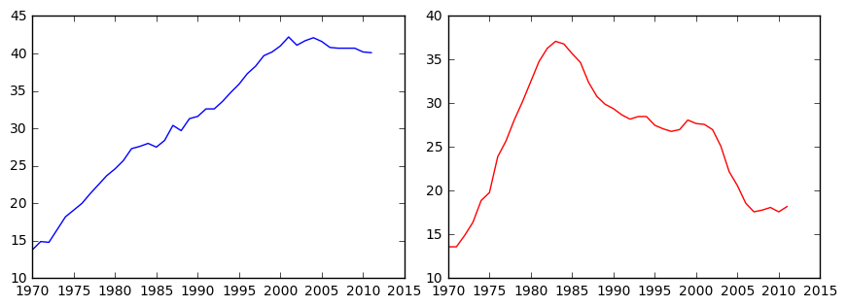

Using subplot()
- The command plt.axes() requires a lot of effort to use well because the coordinates of the axes need to be set manually. A better alternative is to use plt.subplot() to determine the layout automatically.
- plt.subplot(m, n, k) to make the subplot grid of dimensions m by n and to make the kth subplot active (subplots are numbered starting from 1 row-wise from the top left corner of the subplot grid).
plt.figure(figsize=[9,3])

# Create a figure with 1x2 subplot and make the left subplot active
plt.subplot(1,2,1)

# Plot in blue the % of degrees awarded to women in the Physical Sciences
plt.plot(year, physical_sciences, color='blue')
plt.title('Physical Sciences')

# Make the right subplot active in the current 1x2 subplot grid
plt.subplot(1,2,2)

# Plot in red the % of degrees awarded to women in Computer Science
plt.plot(year, computer_science, color='red')
plt.title('Computer Science')

# Use plt.tight_layout() to improve the spacing between subplots
plt.tight_layout()
plt.show()
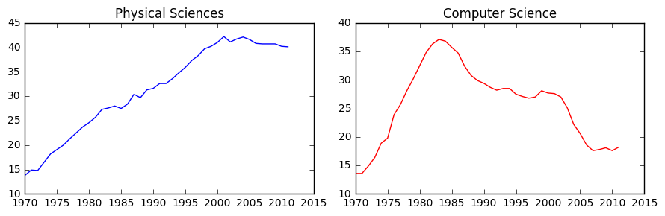

add more data
health (representing the percentage of Computer Science degrees awarded to women in each corresponding year
education
health = np.array([ 77.1, 75.5, 76.9, 77.4, 77.9, 78.9, 79.2, 80.5, 81.9,
82.3, 83.5, 84.1, 84.4, 84.6, 85.1, 85.3, 85.7, 85.5,
85.2, 84.6, 83.9, 83.5, 83. , 82.4, 81.8, 81.5, 81.3,
81.9, 82.1, 83.5, 83.5, 85.1, 85.8, 86.5, 86.5, 86. ,
85.9, 85.4, 85.2, 85.1, 85. , 84.8])
education = np.array([ 77.1, 75.5, 76.9, 77.4, 77.9, 78.9, 79.2, 80.5, 81.9,
82.3, 83.5, 84.1, 84.4, 84.6, 85.1, 85.3, 85.7, 85.5,
85.2, 84.6, 83.9, 83.5, 83. , 82.4, 81.8, 81.5, 81.3,
81.9, 82.1, 83.5, 83.5, 85.1, 85.8, 86.5, 86.5, 86. ,
85.9, 85.4, 85.2, 85.1, 85. , 84.8])

2x2 subplot layout
# Create a figure with 2x2 subplot layout and make the top left subplot active
plt.subplot(2,2,1)

# Plot in blue the % of degrees awarded to women in the Physical Sciences
plt.plot(year, physical_sciences, color='blue')
plt.title('Physical Sciences')

# Make the top right subplot active in the current 2x2 subplot grid
plt.subplot(2,2,2)

# Plot in red the % of degrees awarded to women in Computer Science
plt.plot(year, computer_science, color='red')
plt.title('Computer Science')

# Make the bottom left subplot active in the current 2x2 subplot grid
plt.subplot(2,2,3)

# Plot in green the % of degrees awarded to women in Health Professions
plt.plot(year, health, color='green')
plt.title('Health Professions')

# Make the bottom right subplot active in the current 2x2 subplot grid
plt.subplot(2,2,4)

# Plot in yellow the % of degrees awarded to women in Education
plt.plot(year, education, color='yellow')
plt.title('Education')

# Improve the spacing between subplots and display them
plt.tight_layout()
plt.show()
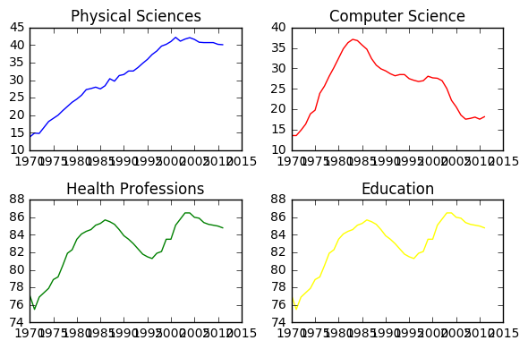

Using xlim(), ylim()
- set x- and y-limits of plots, e.g. plt.xlim() to set the x-axis range
plt.figure(figsize=[9,3])

# Plot the % of degrees awarded to women in Computer Science and the Physical Sciences
plt.plot(year,computer_science, color='red')
plt.plot(year, physical_sciences, color='blue')

# Add the axis labels
plt.xlabel('Year')
plt.ylabel('Degrees awarded to women (%)')

# Set the x-axis range
plt.xlim([1990,2010])

# Set the y-axis range
plt.ylim([0,50])

# Add a title and display the plot
plt.title('Degrees awarded to women (1990-2010)\nComputer Science (red)\nPhysical Sciences (blue)')
plt.show()

# Save the image as 'xlim_and_ylim.png'
plt.savefig('xlim_and_ylim.png')
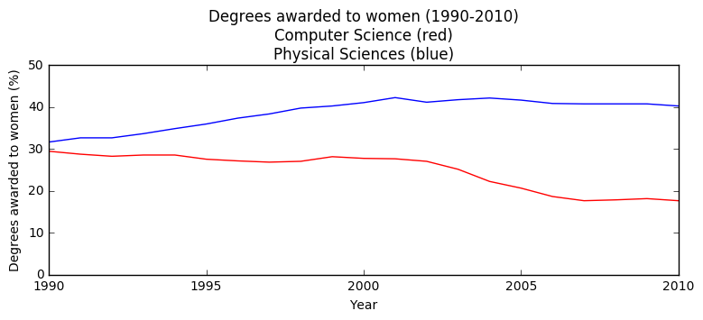
<matplotlib.figure.Figure at 0x7f32a7dca850>

Using axis()
- alternatively, you can pass a 4-tuple to plt.axis() to set limits for both axes at once.
- save plot using savefig()
plt.figure(figsize=[7,3])

# Plot in blue the % of degrees awarded to women in Computer Science
plt.plot(year,computer_science, color='blue')

# Plot in red the % of degrees awarded to women in the Physical Sciences
plt.plot(year, physical_sciences,color='red')

# Set the x-axis and y-axis limits
plt.axis((1990,2010,0,50))

# Show the figure
plt.show()

# Save the figure as 'axis_limits.png'

plt.savefig('axis_limits.png')
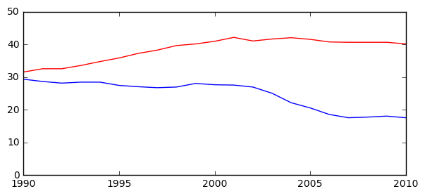
<matplotlib.figure.Figure at 0x7f32a7e68e90>

Other axis() options
Invocation | Result
axis(‘off’) | turns off axis lines, labels
axis(‘equal’) | equal scaling on x, y axes
axis(‘square’) | forces square plot
axis(‘tight’) | sets xlim(), ylim() to show all data
plt.figure(figsize=[20,3])
plt.subplot(1,2,1)

# Plot in blue the % of degrees awarded to women in Computer Science
plt.plot(year,computer_science, color='blue')
# Plot in red the % of degrees awarded to women in the Physical Sciences
plt.plot(year, physical_sciences,color='red')
# Set the x-axis and y-axis limits
plt.axis('equal')

plt.subplot(1,2,2)

# Plot in blue the % of degrees awarded to women in Computer Science
plt.plot(year,computer_science, color='blue')
# Plot in red the % of degrees awarded to women in the Physical Sciences
plt.plot(year, physical_sciences,color='red')
# Set the x-axis and y-axis limits
plt.axis('tight')

# Show the figure
plt.show()
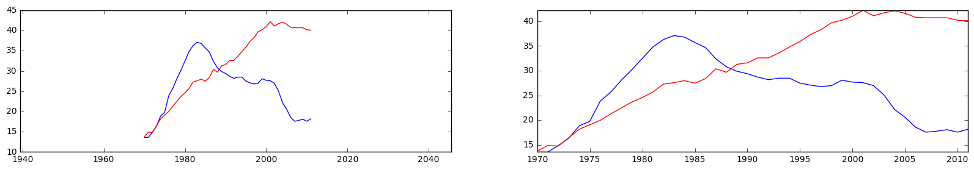

Using legend()
plt.figure(figsize=[7,2.5])

# Specify the label 'Computer Science'
plt.plot(year, computer_science, color='red', label='Computer Science')

# Specify the label 'Physical Sciences'
plt.plot(year, physical_sciences, color='blue', label='Physical Sciences')

# Add a legend at the lower center
plt.legend(loc='upper right')

# Add axis labels and title
plt.xlabel('Year')
plt.ylabel('Enrollment (%)')
plt.title('Undergraduate enrollment of women')
plt.show()
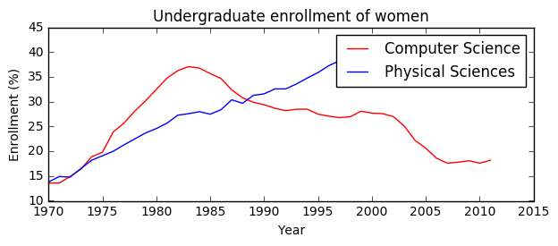

Legend locations
string | code | string | code | string | code
'upper left' | 2 | 'upper center' | 9 | 'upper right' | 1
'center left' | 6 | 'center' ' | 10 | 'center right' | 7
'lower left' | 3 | 'lower center' | 8 | 'lower right' | 4
'best' | 0 |  |  | 'right' | 5

Using annotate()
- To enable an arrow, set arrowprops=dict(facecolor='black'). The arrow will point to the location given by xy and the text will appear at the location given by xytext
plt.figure(figsize=[7,2.5])

# Plot with legend as before
plt.plot(year, computer_science, color='red', label='Computer Science')
plt.plot(year, physical_sciences, color='blue', label='Physical Sciences')
plt.legend(loc='lower right')

# Compute the maximum enrollment of women in Computer Science: cs_max
cs_max = computer_science.max()

# Calculate the year in which there was maximum enrollment of women in Computer Science: yr_max
yr_max = year[computer_science.argmax()]

# Add a black arrow annotation
plt.annotate(s='Maximum', xy=(yr_max, cs_max), xytext=(yr_max-30,cs_max+8), arrowprops={'facecolor':'cyan'})

# Add axis labels and title
plt.xlabel('Year')
plt.ylabel('Enrollment (%)')
plt.title('Undergraduate enrollment of women')
plt.show()
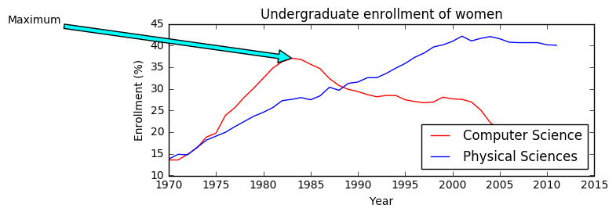

Modifying styles
- Matplotlib comes with a number of different stylesheets to customize the overall look of different plots. To activate a particular stylesheet you can simply call plt.style.use() with the name of the style sheet you want.
- To list all the available style sheets you can execute: print(plt.style.available)
print(plt.style.available)
[u'seaborn-darkgrid', u'seaborn-notebook', u'classic', u'seaborn-ticks', u'dark_background', u'bmh', u'seaborn-talk', u'grayscale', u'ggplot', u'fivethirtyeight', u'seaborn-colorblind', u'seaborn-deep', u'seaborn-whitegrid', u'seaborn-bright', u'seaborn-poster', u'seaborn-muted', u'seaborn-paper', u'seaborn-white', u'seaborn-pastel', u'seaborn-dark', u'seaborn-dark-palette']

set diff style

set smaller font of axis
plt.figure(figsize=[7,2.5])

# Set the style to 'ggplot'
plt.style.use('ggplot')

# Plot the enrollment % of women in Computer Science
plt.plot(year, computer_science, 'ro-',alpha=.2,linewidth=2, markersize=12)
plt.title('Computer Science',fontsize=11,alpha=.8,color='orange')
plt.xlabel('test x lable',fontsize=8,color='g')
plt.ylabel('test y lable',fontsize=9,color='purple',alpha=.8)

plt.tick_params(labelsize=7)

# Add annotation
cs_max = computer_science.max()
yr_max = year[computer_science.argmax()]
plt.annotate('Maximum', xy=(yr_max, cs_max), xytext=(yr_max-1, cs_max-15), arrowprops=dict(facecolor='green'))

# Improve spacing between subplots and display them
plt.tight_layout()
plt.show()
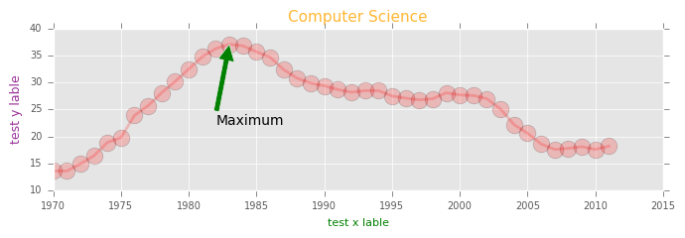

Multiple plots on single axis
It is time now to put together some of what you have learned and combine line plots on a common set of axes. The data set here comes from records of undergraduate degrees awarded to women in a variety of fields from 1970 to 2011. You can compare trends in degrees most easily by viewing two curves on the same set of axes.
Here, three NumPy arrays have been pre-loaded for you: year (enumerating years from 1970 to 2011 inclusive), physical_sciences (representing the percentage of Physical Sciences degrees awarded to women each in corresponding year), and computer_science (representing the percentage of Computer Science degrees awarded to women in each corresponding year).
You will issue two plt.plot() commands to draw line plots of different colors on the same set of axes. Here, year represents the x-axis, while physical_sciences and computer_science are the y-axes.

Instructions
100xp

Instructions
100xp
- Import matplotlib.pyplot as its usual alias.
- Add a 'blue' line plot of the % of degrees awarded to women in the Physical Sciences (physical_sciences) from 1970 to 2011 (year). Note that the x-axis should be specified first.
- Add a 'red' line plot of the % of degrees awarded to women in Computer Science (computer_science) from 1970 to 2011 (year).
- Use plt.show() to display the figure with the curves on the same axes.

SOLUTION>
# Import matplotlib.pyplot
import matplotlib.pyplot as plt

# Plot in blue the % of degrees awarded to women in the Physical Sciences
plt.plot(year, physical_sciences, color='blue')

# Plot in red the % of degrees awarded to women in Computer Science
plt.plot(year, computer_science, color='red')

# Display the plot
plt.show()

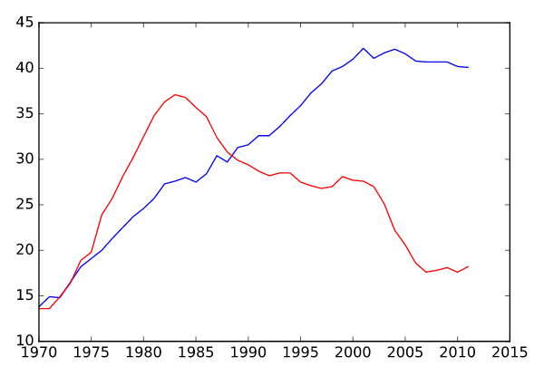

>>>>>>>>>>>>>>>>>>>>>>>>>>>>>>>>>>>>>>>>>>>>>>>>>>>>>>>>>>>>>>>>>>>

Using axes()
Rather than overlaying line plots on common axes, you may prefer to plot different line plots on distinct axes. The command plt.axes() is one way to do this (but it requires specifying coordinates relative to the size of the figure).
Here, you have the same three arrays year, physical_sciences, and computer_science representing percentages of degrees awarded to women over a range of years. You will use plt.axes() to create separate sets of axes in which you will draw each line plot.
In calling plt.axes([xlo, ylo, width, height]), a set of axes is created and made active with lower corner at coordinates (xlo, ylo) of the specified width and height. Note that these coordinates can be passed to plt.axes() in the form of a list or a tuple.
The coordinates and lengths are values between 0 and 1 representing lengths relative to the dimensions of the figure. After issuing a plt.axes() command, plots generated are put in that set of axes.

Instructions
100xp
- Create a set of plot axes with lower corner xlo and ylo of 0.05 and 0.05, width of 0.425, and height of 0.9 (in units relative to the figure dimension).
  - Note: Remember to pass these coordinates to plt.axes() in the form of a list: [xlo, ylo, width, height].
- Plot the percentage of degrees awarded to women in Physical Sciences in blue in the active axes just created.
- Create a set of plot axes with lower corner xlo and ylo of 0.525 and 0.05, width of 0.425, and height of 0.9 (in units relative to the figure dimension).
- Plot the percentage of degrees awarded to women in Computer Science in red in the active axes just created.
SOLUTIONS
# Create plot axes for the first line plot
plt.axes([0.05, 0.05, 0.425, 0.9])

# Plot in blue the % of degrees awarded to women in the Physical Sciences
plt.plot(year, physical_sciences, color='blue')

# Create plot axes for the second line plot
plt.axes([.525,0.05,0.425,0.9])

# Plot in red the % of degrees awarded to women in Computer Science
plt.plot([0.525, 0.05, 0.425, 0.9])

# Display the plot
plt.show()





